University of Utah
School of Computing
CS 6967: Security Operations

Name: Syeda Mishra Saiara
uID: u1457424

Lab 12 Response Outline

Lab 12: Threat Hunting with Network Data
Test 1: Test the Pcap
Summary of test experience:
The goal of this lab is to get familiar with network forensics. As a preparation step, I installed Wireshark and tcpdump in my Kali Linux vm.
For this test a file was given for analyzing the network traffic between the DHCP server and the host machine. The file was uploaded in wireshark after running wireshark from the Kali Linux terminal. The filter “dhcp.option.requested_ip_address” was applied which is used for the information of client MAC address and the requested IPv4 address from the server.
Screenshot of test results:
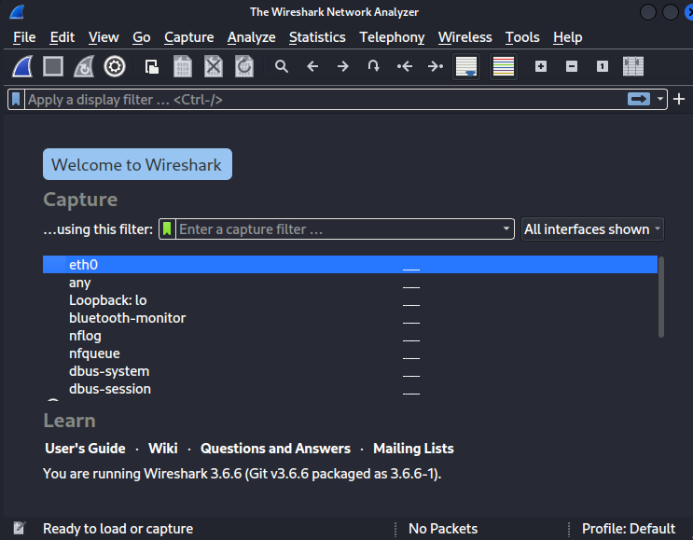
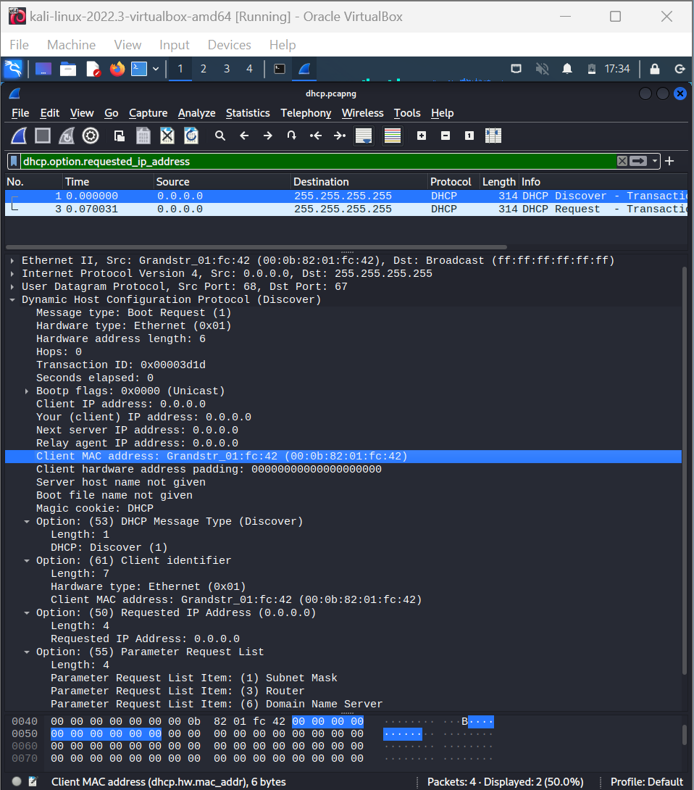
How does the image demonstrate that you completed the test?
After running the command, it showed the client MAC address which matched the one in the given instruction. The requested IP was supposed to be the IP of client. But since it's a DHCP protocol, the address 0.0.0.0 is also accepted.

Test 2: Use Tcpdump
Summary of test experience:
The next test is a repeat of the first test only by using tcpdump and from the Kali Linux terminal instead of wireshark. After running the command tcpdump -r /home/kali/Desktop/dhcp.pcapng port 67 or port 68 -e -n -vv the packet analysis from the file given was shown with details.
Screenshot of test results:
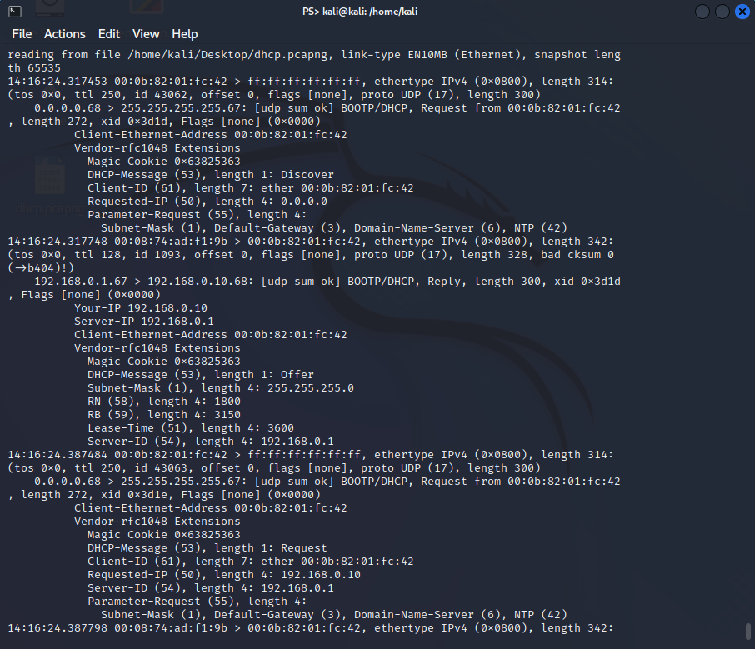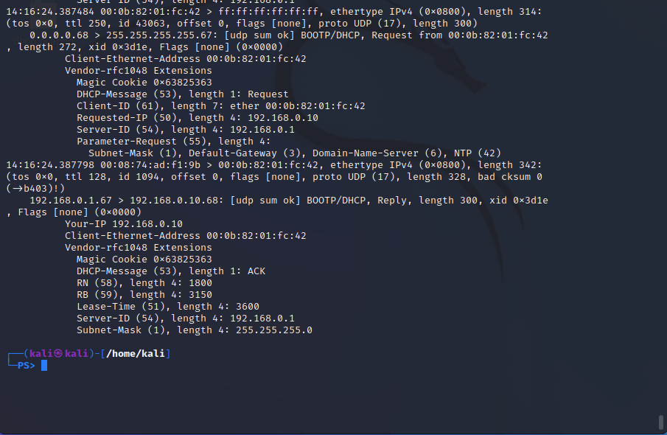

How does the image demonstrate that you completed the test?
The screenshots provide the information of the interactions between the client IP 192.168.0.10 domain and the DHCP server. It also shows the client ethernet address which matches the one provided in the screenshot.
Test 3: Test the Pcap
Summary of test experience:
The goal of this test was also the same as the previous ones, only this time the netbios traffic between a host machine and another machine is included in the file, which explains the netbios traffic. Because, netbios(network Basic Input/Output System) communication protocol allows applications, computers, and devices on a local area network (LAN) to communicate with each other.
I loaded the given file in wireshark like before but with the filter nbns.name this time.
Screenshot of test results:
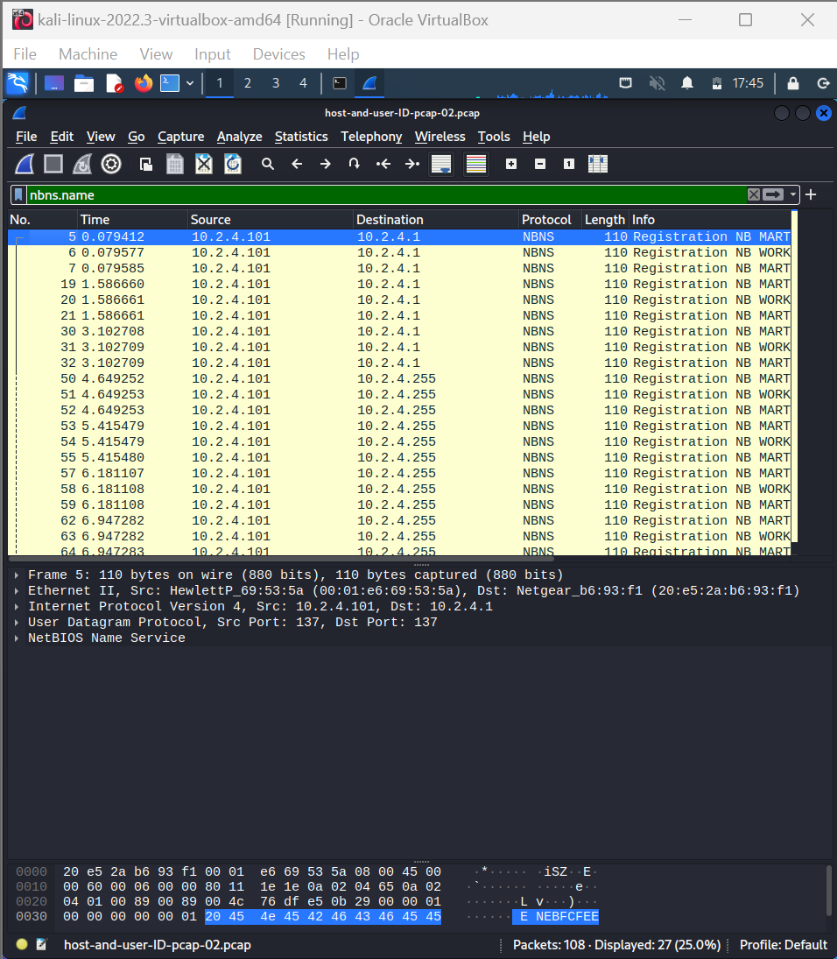
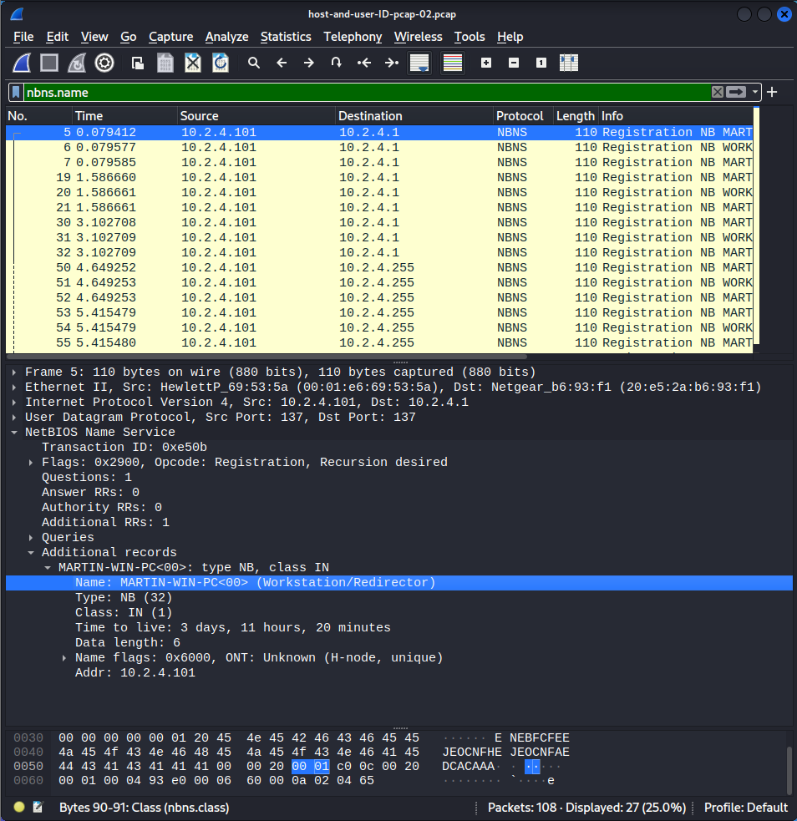

How does the image demonstrate that you completed the test?
The screenshot provides the communication between the machines with the IPs of source and destination addresses. The selected part of the second image shows that the device named MARTIN-WIN-PC is registering its NetBIOS name with the network. The device broadcasts its presence on the network and links its name to IP address 10.2.4.101 as part of the NetBIOS name registration process.

Test 4: Use Tshark
Summary of test experience:
This test is the repeat of test 3 using Tshark, which is the command line tool of wireshark. After running the command tshark -r /path/to/your/pcap -Y nbns -T fields -E header=y -e ip.src -e ip.dst -e nbns.name the terminal showed the netbios name between the source and the destination IP (host machine and the destination machine).
Screenshot of test results:
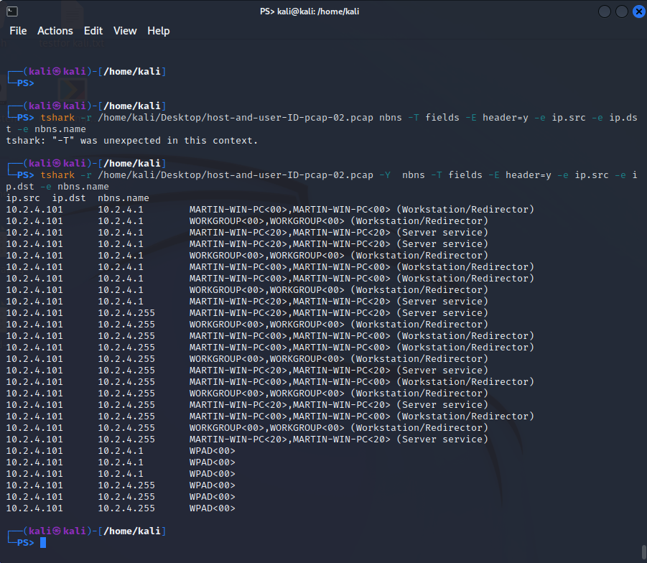

How does the image demonstrate that you completed the test?
The screenshot shows communication between 10.2.4.101 and 10.2.4.1/255, and the name of the netbios traffic started from MARTIN-WIN-PC.

Test 5: Test the Pcap
Summary of test experience:
Next part of the test is to analyze the http traffic between a server and client using Kali Linux and need to figure out the remote host (domain name), the user-agent, and the requested URL. I loaded the file in similar way as before in wireshark and gave the filter http.request and !(ssdp) as instructed.
Screenshot of test results:
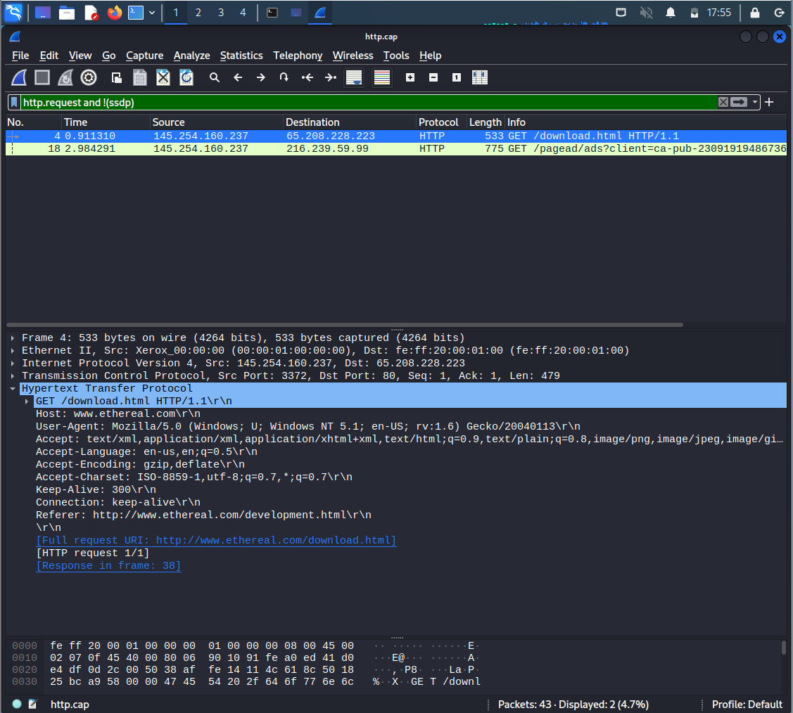
How does the image demonstrate that you completed the test?
It shows the http protocols in the traffic file, which is a GET request, typically used for loading or retrieving contents from a server without modifying the data. It also shows the user agent, which in this case is a client likely from Mozilla browser in a windows operating system using Gecko rendering engine.

Test 6: Use Tcpdump
Summary of test experience:
This is a repeat of test 5 using tcpdump. I ran the command tcpdump -r http.cap -A -s 10240 'tcp port 80 and (((ip[2:2] - ((ip[0]&0xf)<<2)) - ((tcp[12]&0xf0)>>2)) != 0)' in my Kali Linux terminal.
Screenshot of test results:
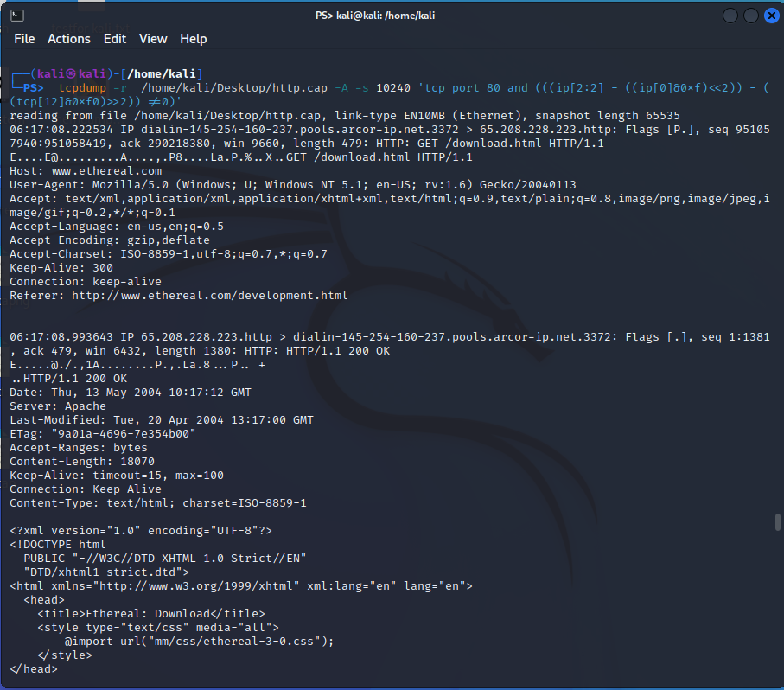
How does the image demonstrate that you completed the test?
The first part after the command shows the same information as stated in the previous test. The client is a Mozilla browser compatible in a windows system and using Gecko rendering engine.

Test 7: Follow the TCP Stream
Summary of test experience:
This test is just to follow the TCP stream or the continuation of the interactions made between the client and server. The test was done by following the TCP stream from the wireshark by loading the file and giving the filter tcp.stream eq 1.
Screenshot of test results:
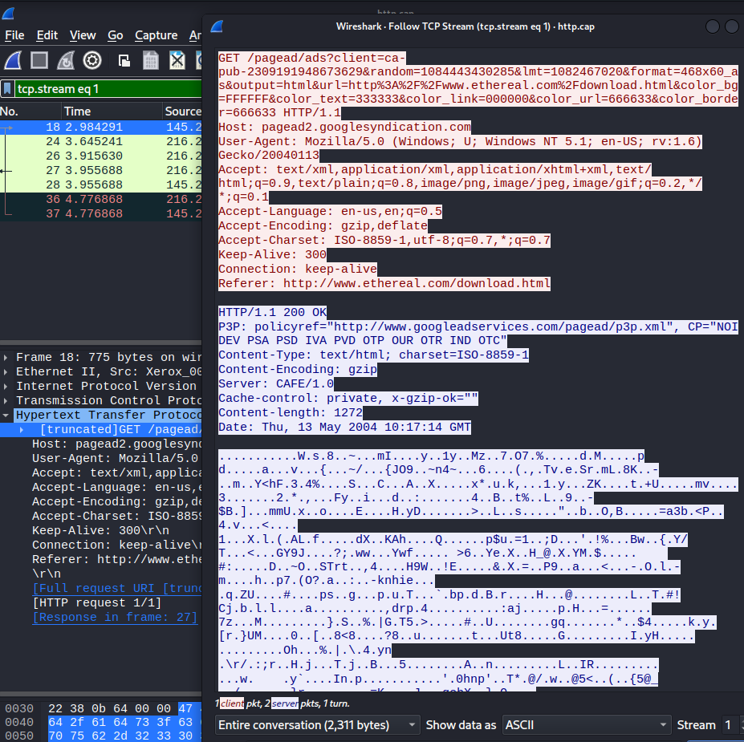
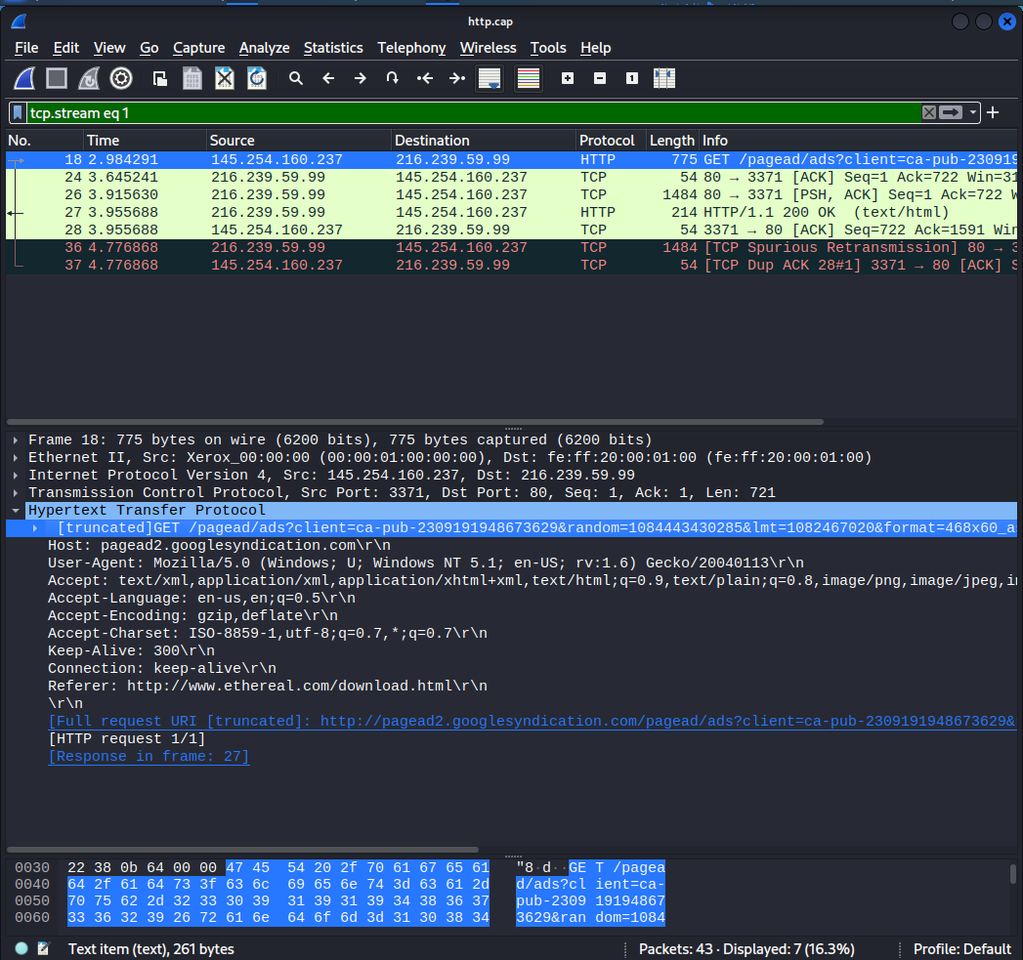

How does the image demonstrate that you completed the test?
The screenshot shows after the GET request from the client, there is a http 200 Ok server request made. This simply is an http from the server side when the request from the client is accepted.

